

### PROJECT REPORT

ON

**“TRAVEL MANAGER”**

## Submitted To: Submitted By:

Ms. Anita Narwal Abhimanyu Raj (23CSE03)

Arpit Awasthi (23CSE56)

Garvit Upadhyay (23CSE56)

### DEPARTMENT OF COMPUTER SCIENCE AND ENGINEERING ARAVALI COLLEGE OF ENGINEERING AND MANAGEMENT FARIDABAD – 121002

Nov-2024

# ACKNOWLEDGEMENT

This project would not have taken shape, without the guidance provided by **Ms. Anita Narwal,** our mentor who helped us in our project for their invaluable guidance and support throughout the development and resolved all the technical problems related to our project and, for the opportunity and provided us all the academic, and conceptual support for our Project.

**ABSTRACT**

This project presents the development of a comprehensive web-based Travel Management System designed to streamline and travel planning processes. The system addresses the growing need for centralized travel management solutions in where all the services are present together for user. By implementing modern web technologies like HTML and CSS for the frontend. Special emphasis has been placed on user experience design, implementing responsive interfaces that function seamlessly across desktop and mobile devices.

# TABLE OF CONTENTS

## 1. INTRODUCTION 11

1.1 Objective of Proposed System

1.2 Scope of the Proposed System

1.3 Feasibility Study.

1.3.1 Technical Feasibility

1.3.2 Economic Feasibility

1.3.3 operational Feasibility

**2. SYSTEM ANALYSIS 15-20**

2.1 User Interface

2.2 H/W Requirements

2.3 S/W Requirements

2.4 Communication interface

* 1. Requirements Specification

2.5.1 Requirements

2.5.2 Safety Requirements

2.5.3 Safety Requirements

## S YSTEM DESIGN 20-25

3.1 System Functionality

3.2 System Modules

## SYSTEM IMPLEMENTATION

5.1 System Coding

## SUMMARY AND CONCLUSIONS

6. Conclusion

6.3 Future Scope

**REFERENCES**

# INTRODUCTION

The travel manager is a website that will cater to a diverse range of users, from solo adventurers to large corporate groups, offering a suite of powerful tools and services. By leveraging cutting-edge technology and partnerships with leading travel providers, our platform will simplify the entire travel process, from the initial spark of inspiration to the final moments of a trip. This comprehensive online platform is designed to be the ultimate travel companion, seamlessly integrating various aspects of trip planning, booking, and management.

This project not only aims to enhance the user experience but also to address common pain points in travel planning and management. By providing a centralized platform for all travel-related needs, we seek to reduce stress, save time, and ultimately make travel more enjoyable and accessible for everyone.

## OBJECTIVE OF THE PROJECT

Objectives of this website are:

1. It allows travel planning and organizing service.
2. To facilitate an intuitive and easy-to-navigate website design.
3. It allows Integrated booking services for flights, accommodations, transportation, and activities.
4. It gives personalized recommendations based on user preferences and past trips.
5. It gives Collaborative tools for group travel planning.
6. It gives Live updates on travel conditions, alerts, and local information, local news.
7. It gives Mobile compatibility for on-the-go access and updates.
8. To Integrate flight, hotel, and car rental booking services.
9. Multiple channels for customer support like chat, email, phone, etc.

## SCOPE OF THE PROPOSED PROJECT

Through Travel Manager, people can bookings, control costs, and implement sustainable travel policies. It is a secure process and beneficial. It reduces time and effort in planning trips, and employees can access travel information easily through their devices. The future scopes and enhancements being considered include using analytical tools and API to offer enterprise-level tools for travel managers to optimize budgets, track spending, and identify cost-saving opportunities. As the platform expands to globally demand for seamless experience while using the service. It can help in tourism activities of regions and places helping people.

## FEASIBILITY STUDY

Feasibility study is the process of determination of whether or not a project is worth doing. Feasibility studies are undertaken within tight time constraints and normally culminate in a written feasibility report. I have taken two weeks in feasibility study with my co-developers. The contents and recommendations of this feasibility study helped us as a sound basis for deciding how to proceed the project. It helped in taking decisions such as which software to use, hardware combinations, etc.

# 3 . SYSTEM ANALYSIS

## USER INTERFACE

* + - Front-end software: HTML, CSS.

## HARDWARE REQUIREMENTS

* + - Pentium IV or higher, (PIV-300GHz recommended)
    - 256 MB RAM
    - 1 Gb hard free drive space.

## SOFTWARE REQUIREMENTS

Following are the software used for Travel Manager:

* + - HTML
    - CSS
    - Visual Studio Code
    - Web Browser: Google Chrome and Mozilla
    - Operating System: Windows 12

## COMMUNICATION INTERFACE

This project supports all types of web browsers. We are using simple electronic forms for the booking of hotels, flights, cruises, cabs etc..

## 3.5 Data Flow Diagram (DFD)

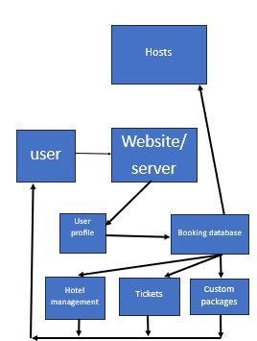It is a directed graph on how the proposed flow of data should take place.

##### 

# 4. SYSTEM DESIGN

#### 4.1 Travel Manger Algorithm Steps

**4.1.1 Landing Page Algorithm**

The landing page is the first point of contact with the user. It should be user-friendly, displaying essential information and allowing users to navigate easily to other sections like booking, destinations, and account settings.

**Steps:**

1. **Load the Landing Page**:

Display a clean, responsive UI with elements like logo, search bar, navigation menu .

1. **Search Bar Interaction**:
   * User enters a destination, travel dates, or other criteria.
   * Autocomplete suggestions should appear as the user types.
2. **Destination & Offer Listings**:
   * Display popular destinations.
   * Each listing should include an image, brief description, and "Book Now" button.
3. **Footer**:
   * Include links to About and Social Media icons.

4.1.2 **Booking Process Algorithm**

Once the user selects an option, proceed with the booking steps.

**Steps:**

1. **Booking Details**:

Show a detailed summary of the booking (e.g., flight/hotel details, dates, price)..

1. **Passenger/Guest Details**:
   * User enters required information for passengers like name, passport info, contact details.
   * For hotels, allow guest information and preferences.
2. **Payment Information**:
   * Collect payment details credit card info, etc.
   * Validate payment details.
3. **Booking Confirmation**:
   * After successful payment, display a confirmation page with booking details.
   1. **SYSTEM MODULES**

The modules used in this software are as follows:

##### Local Address :127.0.0.1:8000/spamclassifier/

.



# 6.SYSTEM IMPLEMENTATION

## 6.1 SYSTEM CODING:

**1.Templates**

**1.1 Home page**

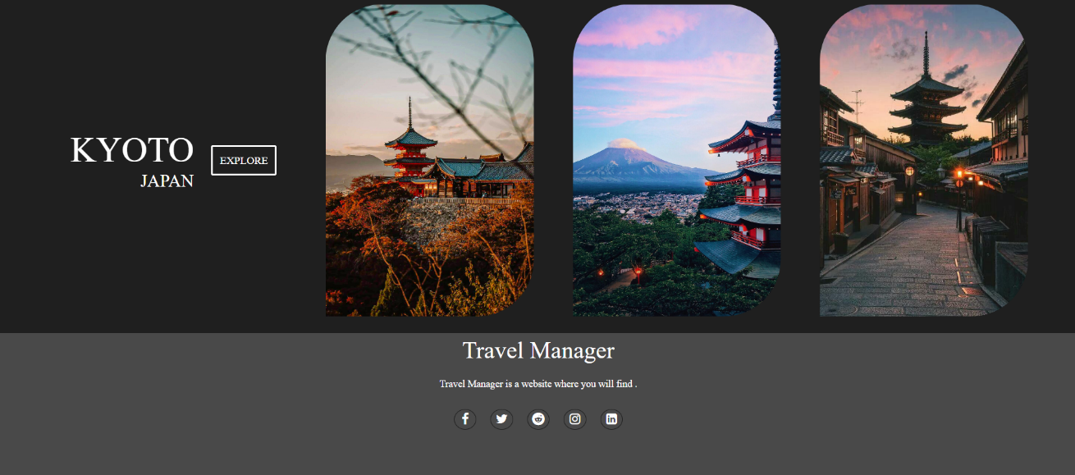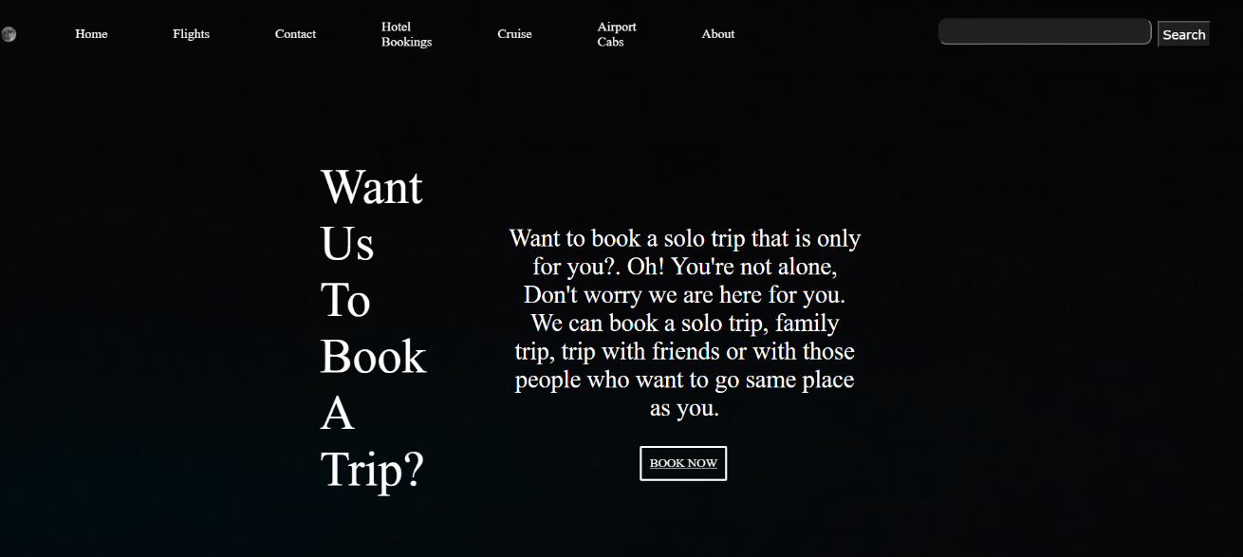

<!DOCTYPE html>

<html lang="en">

   <head>

      <meta charset="UTF=8">

      <meta name="viewport" content="width=device-width",initial scale="1:0">

      <link rel="stylesheet" href="index.css">

      <link rel="stylesheet" href="https://stackpath.bootstrapcdn.com/font-awesome/4.7.0/css/font-awesome.min.css">

   </head>

   <header>

      <nav class="navbar background">

         <ul class="navlinks">

            <div class="logo"><img src="moon.png" alt="logo"></div>

            <li><a href="TravelManager.html">Home</a></li>

            <li><a href="flight.html">Flights</a></li>

            <li><a href="ourcontact.html">Contact</a></li>

            <li><a href="hotel.html">Hotel Bookings</a></li>

            <li><a href="cruise.html">Cruise</a></li>

            <li><a href="cab.html">Airport Cabs</a></li>

            <li><a class="active" href="about.html">About</a></li>

         </ul>

         <div class="rightnav">

            <input type="text" name="search" id="search">

            <button class="btnsm"> Search </button>

         </div>

     </nav>

   </header>

   <body>

      <section class="background cointainer">

         <div class="boxmain">

            <div class="phalf">

               <p class="bigt">

                  Want Us To Book A Trip?

               </p>

               <p class="smallt">

               Want to book a solo trip that is only for you?. Oh! You're not alone, Don't worry we are here for you. We can book a solo trip, family trip, trip with friends or with those people who want to go same place as you.

               </p>

                  <div class="buttons">

                     <button class="btn"><a href=hotel.html>BOOK NOW</a></button>

                  </div>

            </div>

         </div>

      </section>

      <section class="new">

         <div class="paras">

         <p class="valo">KYOTO</p>

         <p class="velo">JAPAN</p>

         </div>

         <div class="seemore">

            <button class="see btn">

               EXPLORE

            </button>

         </div>

         <div class="jp row">

            <div class="column">

            <img src="kyoto3.jpg" alt="kyoto">

            </div>

            <div class="column">

            <img src="kyoto1.jpg" alt="kyoto2">

            </div>

            <div class="column">

               <img src="kyoto4.jpg" alt="kyoto3">

               </div>

         </div>

      </section>

   </body>

   <footer>

      <div class="footer-content">

          <h3>Travel Manager</h3>

          <p>Travel Manager is a  website where you will find .</p>

          <ul class="socials">

              <li><a href="#"><i class="fa fa-facebook"></i></a></li>

              <li><a href="#"><i class="fa fa-twitter"></i></a></li>

              <li><a href="#"><i class="fa fa-reddit"></i></a></li>

              <li><a href="#"><i class="fa fa-instagram"></i></a></li>

              <li><a href="#"><i class="fa fa-linkedin-square"></i></a></li>

          </ul>

      </div>

      <div class="footer-bottom background">

          <p>copyright &copy;2024 <a href="#">Travel Manager</a>  </p>

      </div>

   </footer>

</html>

*{

    padding: 0;

    margin: 0;

}

.background {

    background: rgba(11, 11, 11, 0.7) url(yo.jpg);

    background-size: cover;

    background-blend-mode: darken;

    background-color: black;

}

.body {

    background-color: rgb(249, 247, 247);

    color: white;

    font-size: 20px;

}

.container {

    width: 97.35%;

    margin: 0px auto;

    color: #fefcfc;

    background-color: rgb(32, 32, 32);

    padding: 20px 20px 20px 20px;

}

.logo {

    display: flex;

    width: 20%;

}

.logo img {

    width: 40%;

    border-radius: 200%;

}

.navbar {

    display: flex;

    cursor: pointer;

    top: 0px;

    align-items: center;

    justify-content: center;

    position: sticky;

    top: 0;

}

.navbar ul {

    width: 65%;

    display: flex;

    justify-content: center;

    align-items: center;

}

.navbar ul li {

    list-style: none;

    display: flex;

    padding: 23px 40px;

}

.navbar li a {

    text-decoration: none;

    color: white;

    cursor: pointer;

    transition: transform 0.2s ease, box-shadow 0.2s ease;

}

.navbar li a:hover {

    text-decoration: none;

    transform: scale(1.3);

    box-shadow: 0 5px 15px rgba(0, 0, 0, 0.2);

}

.rightnav {

    width: 35%;

    text-align: right;

    padding: 0px 40px;

    color: black;

}

#search {

    padding: 3px;

    font-size: 20px;

    border-radius: 10px;

    background-color: rgb(32, 32, 32);

    cursor: pointer;

}

#search:hover {

    box-shadow: 0 5px 15px rgba(0, 0, 0, 0.2);

}

.btnsm {

    font-family: Verdana, Geneva, Tahoma, sans-serif;

    padding: 5px;

    font-size: 15px;

    margin: 3px;

    vertical-align: middle;

    color: white;

    background-color: rgb(31, 31, 31);

    cursor: pointer;

}

.background

{

    background: rgba(0, 0, 0, 0.7) url(yo.jpg);

    background-size: cover;

    background-blend-mode: darken;

}

.boxmain

{

    display: flex;

    justify-content: center;

    align-items: center;

    display: flex;

    flex-direction: column;

    margin: auto;

    max-width: 50%;

    padding: 100px;

    margin: auto;

}

.phalf

{

    height: 100%;

    display: flex;

}

.ihalf

{

    width: 30%;

}

.ihalf img

{

    width: 300%;

    border-radius: 200%;

}

.bigt

{

    font-size: 60px;

    padding: 10px;

    color: white;

}

.smallt

{

    display: flex;

    font-size: 30px;

    justify-content: center;

    padding: 80px;

    margin: 10px;

    text-align: center;

    color: white;

}

.buttons

{

    display: flex;

    margin: 10px;

    position: absolute;

    padding: 350px 390px;

}

.btn{

    padding: 10px;

    font-family: 'Times New Roman', Times, serif;

    border-radius: 2px;

    font-size: 15px;

    background: none;

    color: white;

    border: 3px solid white;

    cursor: pointer;

    transition: transform 0.2s ease, box-shadow 0.2s ease;

}

.btn:hover

{

    transform: scale(1.1);

    box-shadow: 0 5px 15px rgba(0, 0, 0, 0.2);

}

.btn a:visited

{

    color: white;

}

.btn a:active

{

    color: red;

}

.valo

{

    font-size: 50px;

    color: white;

}

.velo

{

    font-size: 25px;

    color: white;

}

.new

{

    margin: auto;

    display: flex;

    justify-content: space-evenly;

    align-items: center;

    height: 70vh;

    padding: 0px 100px;

    width: 89.5%;

    background-color: rgb(31, 31, 31);

}

.jp

{

    font-size: 20px;

    box-sizing: border-box;

}

.jp img

{

    width: 90%;

    border-radius: 90px 90px 90px 0px;

    display: flex;

    justify-content: left;

    box-sizing: border-box;

    padding: 10px;

}

.see:hover

{

    background-color: transparent;

}

.paras

{

    width: 20%;

    text-align: right;

}

.seemore

{

    width: 30%;

    justify-content: center;

    display: flex;

}

.row

{

    display: flex;

}

.column

{

    flex: 50%;

    display: flex;

    align-items: center;

    justify-content: right;

    cursor: pointer;

}

.footer {

    position: absolute;

    bottom: 0;

    left: 0;

    right: 0;

    background: #ffffff;

    height: auto;

    width: 97.5vw;

    box-sizing: border-box;

    padding-top: 40px;

    color: rgb(31, 31, 31);

}

.footer-content {

    display: flex;

    align-items: center;

    justify-content: center;

    flex-direction: column;

    text-align: center;

    background-color: rgb(73, 73, 73)

}

.footer-content h3 {

    font-size: 2.1rem;

    font-weight: 500;

    text-transform: capitalize;

    line-height: 3rem;

    color: white;

}

.footer-content p {

    max-width: 500px;

    margin: 10px auto;

    line-height: 28px;

    font-size: 14px;

    color: white;

}

.socials {

    list-style: none;

    display: flex;

    align-items: center;

    justify-content: center;

    margin: 1rem 0 3rem 0;

}

.socials li {

    margin: 0 10px;

}

.socials a {

    text-decoration: none;

    color: white;

    border: 1.1px solid rgb(31, 31, 31);

    padding: 5px;

    border-radius: 50%;

}

.socials a i {

    font-size: 1.1rem;

    width: 20px;

    transition: transform 0.2s ease, box-shadow 0.2s ease;

}

.socials a:hover i {

    color: white;

    transform: scale(1.3);

    box-shadow: 0 5px 15px rgba(0, 0, 0, 0.2);

}

.footer-bottom

{

    background: rgb(73, 73, 73);

    width: 98.9vw;

    padding: 20px;

    padding-bottom: 40px;

    text-align: center;

    padding: 20px 0;

}

.footer-bottom p {

    font-size: 20px;

    word-spacing: 2px;

    text-transform: capitalize;

    text-align: center;

}

.footer-bottom p a {

    color: rgb(49, 23, 220);

    font-size: 16px;

    text-decoration: none;

}

@media (max-width:500px) {

    .footer-menu ul {

        display: flex;

        margin-top: 10px;

        margin-bottom: 20px;

    }

}

**1.2 Contact page**

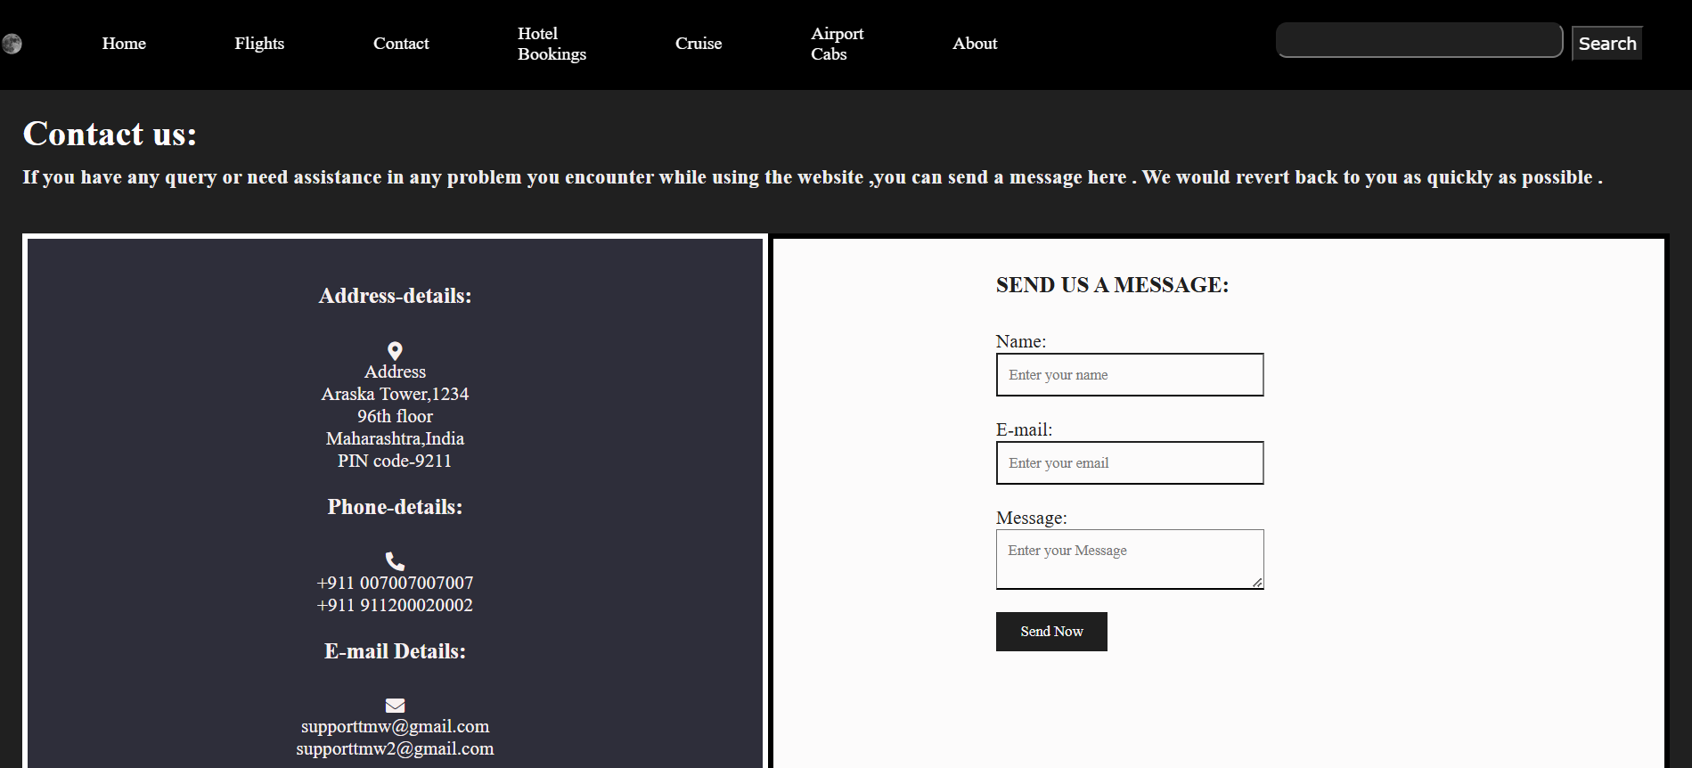



<html>

    <head>

         <meta charset="UTF=8">

        <meta name="viewport" content="width=device-width",initial scale="1:0">

        <link rel="stylesheet" href="ourcontact.css">

        <link rel="stylesheet" href="https://cdnjs.cloudflare.com/ajax/libs/font-awesome/5.15.4/css/all.min.css">

        <link rel="stylesheet" href="https://stackpath.bootstrapcdn.com/font-awesome/4.7.0/css/font-awesome.min.css">

    </head>

    <body>

        <nav class="navbar background">

            <ul class="navlinks">

               <div class="logo"><img src="moon.png" alt="logo"></div>

               <li><a href="proj.html">Home</a></li>

               <li><a href="flight.html">Flights</a></li>

               <li><a href="ourcontact.html">Contact</a></li>

               <li><a href="hotel.html">Hotel Bookings</a></li>

               <li><a href="cruise.html">Cruise</a></li>

               <li><a href="cab.html">Airport Cabs</a></li>

               <li><a class="active" href="about.html">About</a></li>

            </ul>

            <div class="rightnav">

               <input type="text" name="search" id="search">

               <button class="btnsm"> Search </button>

            </div>

        </nav>

        <div class="container">

            <h1>Contact us:</h1>

            <h3><p>If you have any query or need assistance in any problem you encounter while using the website ,you can send a message here . We would revert back to you as quickly as possible .</p></h3>

            <div class="content">

                <div class="content-left">

                    <h3>Address-details:</h3><br>

                        <i class="fas fa-map-marker-alt"></i>

                        <div class="details">Address</div>

                        <div class="text-one">Araska Tower,1234</div>

                        <div class="text-two">96th floor<br>Maharashtra,India<br>PIN code-9211</div><br>

                    <h3>Phone-details:</h3><br>

                        <i class="fas fa-phone-alt"></i>

                        <div class="details"></div>

                        <div class="text-one">+911 007007007007</div>

                        <div class="text-two">+911 911200020002</div>

                        <br>

                    <h3>E-mail Details:</h3><br>

                        <i class="fas fa-envelope"></i>

                        <div class="details"></div>

                        <div class="text-one">supporttmw@gmail.com</div>

                        <div class="text-two">supporttmw2@gmail.com</div>

                </div>

                <div class="content-right">

                    <div class="input-row">

                    <div class="omega">

                    <form action="#">

                        <h3>SEND US A MESSAGE:</h3><br>

                        <div class="input-box">

                            <label for="name">Name:</label>

                            <input type="text" id="name" placeholder="Enter your name">

                        </div>

                        <div class="input-box">

                            <label for="email">E-mail:</label>

                            <input type="email" id="email" placeholder="Enter your email">

                        </div>

                        <div class="input-box">

                            <label for="message"> Message:</label>

                            <textarea id="message" placeholder="Enter your Message"></textarea>

                        </div>

                        <div class="button">

                            <input type="submit" value="Send Now">

                        </div>

                    </form>

                    </div>

                    </div>

                </div>

            </div>

        </div>

    </body>

    <footer>

        <div class="footer-content">

            <h3>Travel Manager</h3>

            <p>Travel Manager is a  website where you will find .</p>

            <ul class="socials">

                <li><a href="#"><i class="fa fa-facebook"></i></a></li>

                <li><a href="#"><i class="fa fa-twitter"></i></a></li>

                <li><a href="#"><i class="fa fa-reddit"></i></a></li>

                <li><a href="#"><i class="fa fa-instagram"></i></a></li>

                <li><a href="#"><i class="fa fa-linkedin-square"></i></a></li>

            </ul>

        </div>

        <div class="footer-bottom">

            <p>copyright &copy;2024 <a href="#">Travel Manager</a>  </p>

        </div>

    </footer>

</html>

* {

    margin: 0;

    padding: 0;

    font-family: 'Times New Roman', Times, serif;

}

.background {

    background: rgba(252, 251, 251, 0.7) url(yo.jpg);

    background-size: cover;

    background-blend-mode: darken;

    background-color: black;

}

.body {

    background-color: rgb(249, 247, 247);

    color: white;

    font-size: 20px;

}

.container {

    width: 97.35%;

    margin: 0px auto;

    color: #fefcfc;

    background-color: rgb(32, 32, 32);

    padding: 20px 20px 20px 20px;

}

.logo {

    display: flex;

    width: 20%;

}

.logo img {

    width: 40%;

    border-radius: 200%;

}

.navbar {

    display: flex;

    cursor: pointer;

    top: 0px;

    align-items: center;

    justify-content: center;

    position: sticky;

    top: 0;

}

.navbar ul {

    width: 65%;

    display: flex;

    justify-content: center;

    align-items: center;

}

.navbar ul li {

    list-style: none;

    display: flex;

    padding: 23px 40px;

}

.navbar li a {

    text-decoration: none;

    color: white;

    cursor: pointer;

    transition: transform 0.2s ease, box-shadow 0.2s ease;

}

.navbar li a:hover {

    text-decoration: none;

    transform: scale(1.3);

    box-shadow: 0 5px 15px rgba(0, 0, 0, 0.2);

}

.rightnav {

    width: 35%;

    text-align: right;

    padding: 0px 40px;

    color: black;

}

#search {

    padding: 3px;

    font-size: 20px;

    border-radius: 10px;

    background-color: rgb(32, 32, 32);

    cursor: pointer;

}

#search:hover {

    box-shadow: 0 5px 15px rgba(0, 0, 0, 0.2);

}

.btnsm {

    font-family: Verdana, Geneva, Tahoma, sans-serif;

    padding: 5px;

    font-size: 15px;

    margin: 3px;

    vertical-align: middle;

    color: white;

    background-color: rgb(31, 31, 31);

    cursor: pointer;

}

.content {

    background: rgb(46, 46, 58);

    display: flex;

    height: auto;

}

.content-left {

    flex-basis: 50%;

    padding: 40px 60px;

    color: rgb(247, 240, 240);

    border: 5px solid white;

    text-align: center;

    font-size: 17px;

}

.container h3 p {

    color: #eeeded;

}

.content-right {

    flex-basis: 50%;

    padding: 30px 60px 50px 200px;

    background: rgb(252, 251, 251);

    color: rgb(31, 31, 31);

    border: 5px solid black;

    text-align: left;

    font-size: 17px;

    justify-content: center;

}

h1,

h3 {

    margin-bottom: 10px;

}

.container p {

    margin-bottom: 40px;

    color: #151414;

}

.input-row {

    display: flex;

    justify-content: space-between;

    margin-bottom: 20px;

    flex-basis: 40%;

}

.input-box input,

.input-box textarea {

    width: 100%;

    border: 2 solid black;

    border-bottom: 2px solid black;

    outline: none;

    padding: 10px;

    margin-bottom: 20px;

    background: transparent;

    color: rgb(31, 31, 31);

}

.button input[type="submit"] {

    width: 100px;

    background: rgb(31, 31, 31);

    color: #f8f6f6;

    border: none;

    height: 35px;

    cursor: pointer;

}

.footer {

    position: absolute;

    bottom: 0;

    left: 0;

    right: 0;

    background: #ffffff;

    height: auto;

    width: 97.5vw;

    box-sizing: border-box;

    padding-top: 40px;

    color: rgb(31, 31, 31);

}

.footer-content {

    display: flex;

    align-items: center;

    justify-content: center;

    flex-direction: column;

    text-align: center;

    background-color: rgb(73, 73, 73)

}

.footer-content h3 {

    font-size: 2.1rem;

    font-weight: 500;

    text-transform: capitalize;

    line-height: 3rem;

    color: white;

}

.footer-content p {

    max-width: 500px;

    margin: 10px auto;

    line-height: 28px;

    font-size: 14px;

    color: white;

}

.socials {

    list-style: none;

    display: flex;

    align-items: center;

    justify-content: center;

    margin: 1rem 0 3rem 0;

}

.socials li {

    margin: 0 10px;

}

.socials a {

    text-decoration: none;

    color: white;

    border: 1.1px solid rgb(31, 31, 31);

    padding: 5px;

    border-radius: 50%;

}

.socials a i {

    font-size: 1.1rem;

    width: 20px;

    transition: transform 0.2s ease, box-shadow 0.2s ease;

}

.socials a:hover i {

    color: white;

    transform: scale(1.3);

    box-shadow: 0 5px 15px rgba(0, 0, 0, 0.2);

}

.footer-bottom

{

    background: rgb(73, 73, 73);

    width: 98.9vw;

    padding: 20px;

    padding-bottom: 40px;

    text-align: center;

    padding: 20px 0;

}

.footer-bottom p {

    font-size: 20px;

    word-spacing: 2px;

    text-transform: capitalize;

    text-align: center;

}

.footer-bottom p a {

    color: rgb(49, 23, 220);

    font-size: 16px;

    text-decoration: none;

}

@media (max-width:500px) {

    .footer-menu ul {

        display: flex;

        margin-top: 10px;

        margin-bottom: 20px;

    }

}

**1.3 Flight booking page**

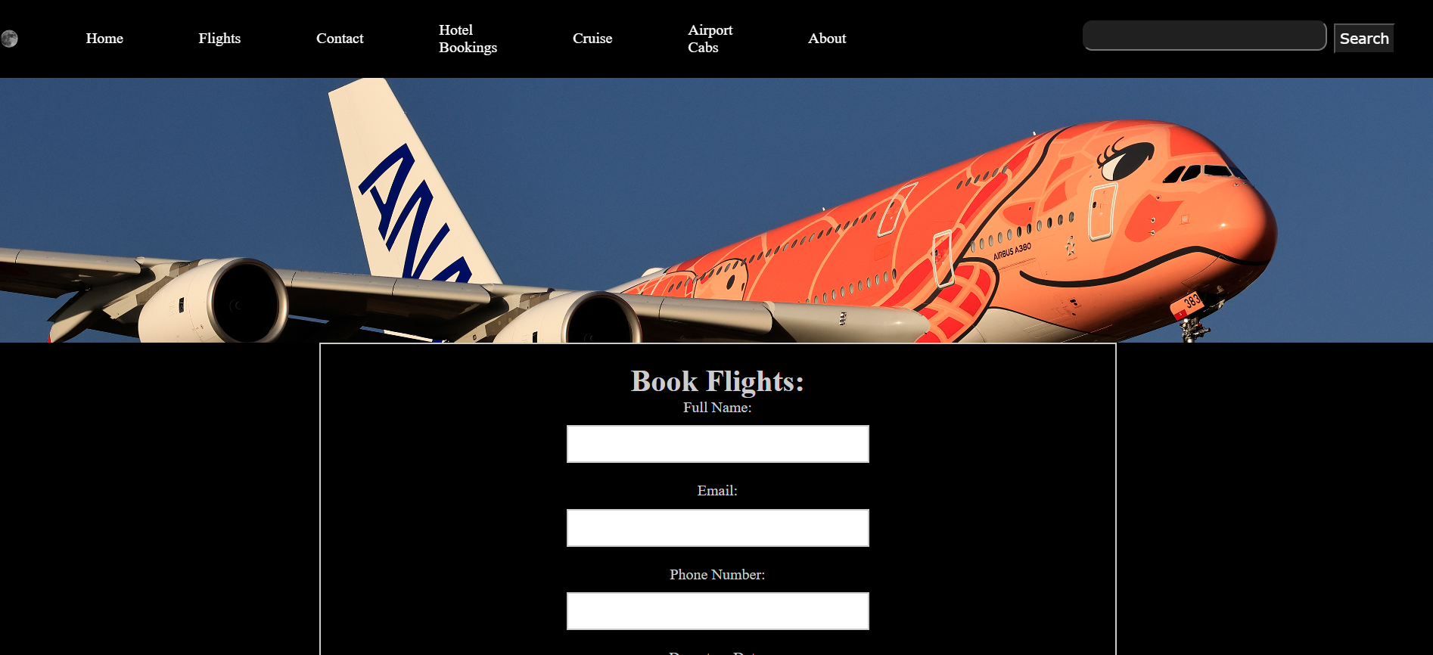

<html>

    <head>

        <link rel="stylesheet" href="flight.css">

        <link rel="stylesheet" href="https://stackpath.bootstrapcdn.com/font-awesome/4.7.0/css/font-awesome.min.css">

    </head>

    <body>

        <nav class="navbar background">

            <ul class="navlinks">

               <div class="logo"><img src="moon.png" alt="logo"></div>

               <li><a href="proj.html">Home</a></li>

               <li><a href="flight.html">Flights</a></li>

               <li><a href="ourcontact.html">Contact</a></li>

               <li><a href="hotel.html">Hotel Bookings</a></li>

               <li><a href="cruise.html">Cruise</a></li>

               <li><a href="cab.html">Airport Cabs</a></li>

               <li><a class="active" href="about.html">About</a></li>

            </ul>

            <div class="rightnav">

               <input type="text" name="search" id="search">

               <button class="btnsm"> Search </button>

            </div>

        </nav>

         <div class="header-image">

            <img src="a380.jpg" alt="header Image" class="header-image">

        </div>

        <div class="omega">

            <div class="booking-form">

                <div class="form-content">

                    <h1>Book Flights:</h1>

                    <form action="#">

                        <label for="name">Full Name:</label>

                        <input type="text" id="name" name="name" required>

                        <label for="email">Email:</label>

                        <input type="email" id="email" name="email" required>

                        <label for="phone">Phone Number:</label>

                        <input type="tel" id="phone" name="phone" required>

                        <label for="departure">Departure Date:</label>

                        <input type="text" id="departure" name="departure" required>

                        <label for="Return">Return Date:</label>

                        <input type="text" id="Return" name="Return" required>

                        <label for="passengers">Passengers:</label>

                        <select id="pax" name="pax" required>

                            <option value="1">1</option>

                            <option value="2">2</option>

                            <option value="3">3</option>

                            <option value="4">4</option>

                            <option value="4+">4+</option>

                        </select>

                        <label for="seat">Class:</label>

                        <select id="seat" name="seat" required>

                            <option value="Economy">Economy</option>

                            <option value="Premium Economy">Premium Economy</option>

                            <option value="Business">Business</option>

                            <option value="first">First</option>

                        </select>

                        <h3>Payment Information</h3>

                        <label for="card-type">Card Type:</label>

                        <select id="card-type" name="card-type">

                            <option value="visa">Visa</option>

                            <option value="mastercard">Mastercard</option>

                            <option value="amex">American Express</option>

                        </select><br><br>

                        <label for="card-number">Card Number:</label>

                        <input type="text" id="card-number" name="card-number"><br><br>

                        <label for="expiration-date">Expiration Date:</label>

                        <input type="date" id="expiration-date" name="expiration-date"><br><br>

                        <button type="submit">Book Now</button>

                    </form>

                </div>

            </div>

        </div>

    </body>

    <footer>

        <div class="footer-content">

            <h3>Travel Manager</h3>

            <p>Travel Manager is a  website where you will find .</p>

            <ul class="socials">

                <li><a href="#"><i class="fa fa-facebook"></i></a></li>

                <li><a href="#"><i class="fa fa-twitter"></i></a></li>

                <li><a href="#"><i class="fa fa-reddit"></i></a></li>

                <li><a href="#"><i class="fa fa-instagram"></i></a></li>

                <li><a href="#"><i class="fa fa-linkedin-square"></i></a></li>

            </ul>

        </div>

        <div class="footer-bottom">

            <p>copyright &copy;2024 <a href="#">Travel Manager</a>  </p>

        </div>

    </footer>

</html>

* {

    margin: 0;

    padding: 0;

    font-family: 'Times New Roman', Times, serif;

}

.background {

    background: rgba(11, 11, 11, 0.7) url(yo.jpg);

    background-size: cover;

    background-blend-mode: darken;

    background-color: black;

}

.body {

    background-color: rgb(249, 247, 247);

    color: white;

    font-size: 20px;

}

.container {

    width: 97.35%;

    margin: 0px auto;

    color: #fefcfc;

    background-color: rgb(32, 32, 32);

    padding: 20px 20px 20px 20px;

}

.logo {

    display: flex;

    width: 20%;

}

.logo img {

    width: 40%;

    border-radius: 200%;

}

.navbar {

    display: flex;

    cursor: pointer;

    top: 0px;

    align-items: center;

    justify-content: center;

    position: sticky;

    top: 0;

}

.navbar ul {

    width: 65%;

    display: flex;

    justify-content: center;

    align-items: center;

}

.navbar ul li {

    list-style: none;

    display: flex;

    padding: 23px 40px;

}

.navbar li a {

    text-decoration: none;

    color: white;

    cursor: pointer;

    transition: transform 0.2s ease, box-shadow 0.2s ease;

}

.navbar li a:hover {

    text-decoration: none;

    transform: scale(1.3);

    box-shadow: 0 5px 15px rgba(0, 0, 0, 0.2);

}

.rightnav {

    width: 35%;

    text-align: right;

    padding: 0px 40px;

    color: black;

}

#search {

    padding: 3px;

    font-size: 20px;

    border-radius: 10px;

    background-color: rgb(32, 32, 32);

    cursor: pointer;

}

#search:hover {

    box-shadow: 0 5px 15px rgba(0, 0, 0, 0.2);

}

.btnsm {

    font-family: Verdana, Geneva, Tahoma, sans-serif;

    padding: 5px;

    font-size: 15px;

    margin: 3px;

    vertical-align: middle;

    color: white;

    background-color: rgb(31, 31, 31);

    cursor: pointer;

}

.omega{

    background: black;

}

.header-image {

    width: 100%;

    height: 280px;

    object-fit: cover;

    border-radius: 0px;

    margin-bottom: 0px;

}

.booking-form {

    max-width: 800px;

    margin: 0px auto;

    padding: 20px;

    background-color: black;

    color:#ccc;

    border: 2px solid #ccc;

    box-shadow: 0 0 10px rgba(0, 0, 0, 0.1);

    display: flex;

    justify-content: center;

  }

  .booking-form .form-content {

    width: 40%;

    text-align: center;

  }

  .booking-form label {

    display: block;

    margin-bottom: 10px;

  }

  .booking-form input[type="text"],

  .booking-form input[type="email"],

  .booking-form input[type="tel"],

  .booking-form select {

    width: 100%;

    height: 40px;

    margin-bottom: 20px;

    padding: 10px;

    border: 2px solid #ccc;

  }

  .booking-form input[type="submit"] {

    width: 100%;

    height: 40px;

    margin-top: 20px;

    padding: 10px;

    background-color: #4CAF50;

    color: #fff;

    border: none;

    border-radius: 5px;

    cursor: pointer;

  }

  .booking-form input[type="submit"]:hover {

    background-color: #3e8e41;

  }

  .footer {

    position: absolute;

    bottom: 0;

    left: 0;

    right: 0;

    background: #ffffff;

    height: auto;

    width: 97.5vw;

    box-sizing: border-box;

    padding-top: 40px;

    color: rgb(31, 31, 31);

}

.footer-content {

    display: flex;

    align-items: center;

    justify-content: center;

    flex-direction: column;

    text-align: center;

    background-color: rgb(73, 73, 73)

}

.footer-content h3 {

    font-size: 2.1rem;

    font-weight: 500;

    text-transform: capitalize;

    line-height: 3rem;

    color: white;

}

.footer-content p {

    max-width: 500px;

    margin: 10px auto;

    line-height: 28px;

    font-size: 14px;

    color: white;

}

.socials {

    list-style: none;

    display: flex;

    align-items: center;

    justify-content: center;

    margin: 1rem 0 3rem 0;

}

.socials li {

    margin: 0 10px;

}

.socials a {

    text-decoration: none;

    color: white;

    border: 1.1px solid rgb(31, 31, 31);

    padding: 5px;

    border-radius: 50%;

}

.socials a i {

    font-size: 1.1rem;

    width: 20px;

    transition: transform 0.2s ease, box-shadow 0.2s ease;

}

.socials a:hover i {

    color: white;

    transform: scale(1.3);

    box-shadow: 0 5px 15px rgba(0, 0, 0, 0.2);

}

.footer-bottom

{

    background: rgb(73, 73, 73);

    width: 98.9vw;

    padding: 20px;

    padding-bottom: 40px;

    text-align: center;

    padding: 20px 0;

}

.footer-bottom p {

    font-size: 20px;

    word-spacing: 2px;

    text-transform: capitalize;

    text-align: center;

}

.footer-bottom p a {

    color: rgb(49, 23, 220);

    font-size: 16px;

    text-decoration: none;

}

@media (max-width:500px) {

    .footer-menu ul {

        display: flex;

        margin-top: 10px;

        margin-bottom: 20px;

    }

}

* 1. **Hotel booking page**

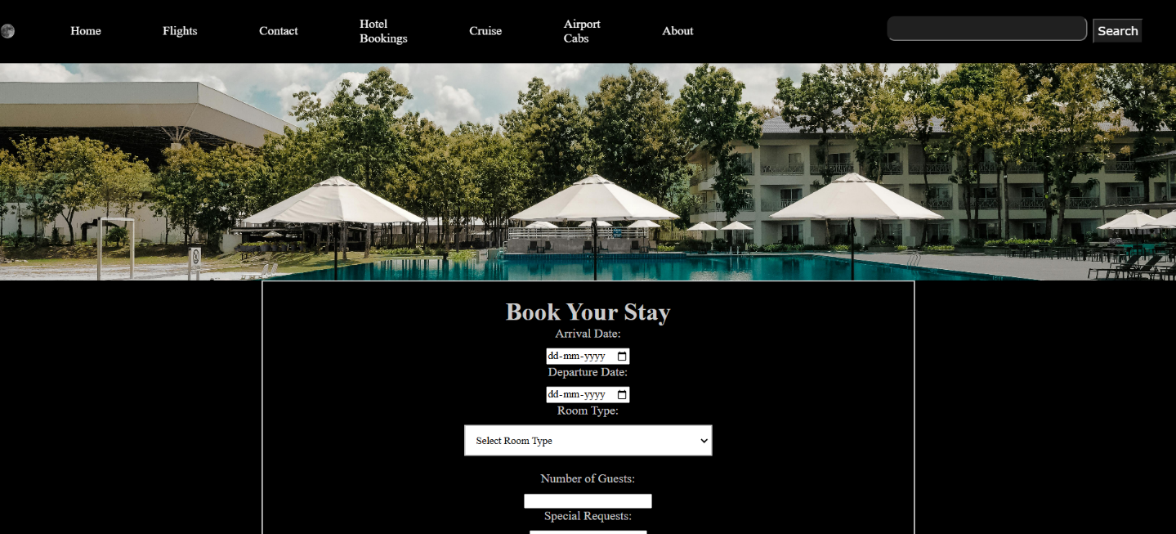

<html>

  <head>

    <link rel="stylesheet" href="hotel.css">

    <link rel="stylesheet" href="https://stackpath.bootstrapcdn.com/font-awesome/4.7.0/css/font-awesome.min.css">

  </head>

  <body>

    <nav class="navbar background">

      <ul class="navlinks">

         <div class="logo"><img src="moon.png" alt="logo"></div>

         <li><a href="proj.html">Home</a></li>

         <li><a href="flight.html">Flights</a></li>

         <li><a href="ourcontact.html">Contact</a></li>

         <li><a href="hotel.html">Hotel Bookings</a></li>

         <li><a href="cruise.html">Cruise</a></li>

         <li><a href="cab.html">Airport Cabs</a></li>

         <li><a class="active" href="about.html">About</a></li>

      </ul>

      <div class="rightnav">

         <input type="text" name="search" id="search">

         <button class="btnsm"> Search </button>

      </div>

    </nav>

    <div class="header-image">

      <img src="hotelkla.jpg" alt="header Image" class="header-image">

    </div>

    <div class="omega">

      <div class="booking-form">

          <div class="form-content">

            <h1>Book Your Stay</h1>

            <div class="form-group">

              <label for="arrival-date">Arrival Date:</label>

              <input type="date" id="arrival-date" name="arrival-date" required>

            </div>

            <div class="form-group">

              <label for="departure-date">Departure Date:</label>

              <input type="date" id="departure-date" name="departure-date" required>

            </div>

            <div class="form-group">

              <label for="room-type">Room Type:</label>

              <select id="room-type" name="room-type" required>

                  <option value="">Select Room Type</option>

                  <option value="single">Single Room</option>

                  <option value="double">Double Room</option>

                  <option value="suite">Suite</option>

              </select>

            </div>

            <div class="form-group">

                <label for="number-of-guests">Number of Guests:</label>

                <input type="number" id="number-of-guests" name="number-of-guests" required>

            </div>

            <div class="form-group">

                <label for="special-requests">Special Requests:</label>

                <textarea id="special-requests" name="special-requests"></textarea>

            </div>

            <div class="form-group">

                <label for="first-name">First Name:</label>

                <input type="text" id="first-name" name="first-name" required>

            </div>

            <div class="form-group">

                <label for="last-name">Last Name:</label>

                <input type="text" id="last-name" name="last-name" required>

            </div>

            <section>

              <h3>Payment Information</h3>

              <label for="card-type">Card Type:</label>

              <select id="card-type" name="card-type">

                <option value="visa">Visa</option>

                <option value="mastercard">Mastercard</option>

                <option value="amex">American Express</option>

              </select><br><br>

              <label for="card-number">Card Number:</label>

              <input type="text" id="card-number" name="card-number"><br><br>

              <label for="expiration-date">Expiration Date:</label>

              <input type="date" id="expiration-date" name="expiration-date"><br><br>

              </section>

              <div class="form-group">

              <label for="email">Email:</label>

              <input type="email" id="email" name="email" required>

              </div>

              <div class="form-group">

              <label for="phone">Phone:</label>

              <input type="tel" id="phone" name="phone" required>

              </div>

              <button type="submit">Book Now</button>

              </form>

          </div>

      </div>

    </div>

  </body>

  <footer>

    <div class="footer-content">

        <h3>Travel Manager</h3>

        <p>Travel Manager is a  website where you will find .</p>

        <ul class="socials">

            <li><a href="#"><i class="fa fa-facebook"></i></a></li>

            <li><a href="#"><i class="fa fa-twitter"></i></a></li>

            <li><a href="#"><i class="fa fa-reddit"></i></a></li>

            <li><a href="#"><i class="fa fa-instagram"></i></a></li>

            <li><a href="#"><i class="fa fa-linkedin-square"></i></a></li>

        </ul>

    </div>

    <div class="footer-bottom">

        <p>copyright &copy;2024 <a href="#">Travel Manager</a>  </p>

    </div>

  </footer>

</html>

* 1. **Cruise booking page**

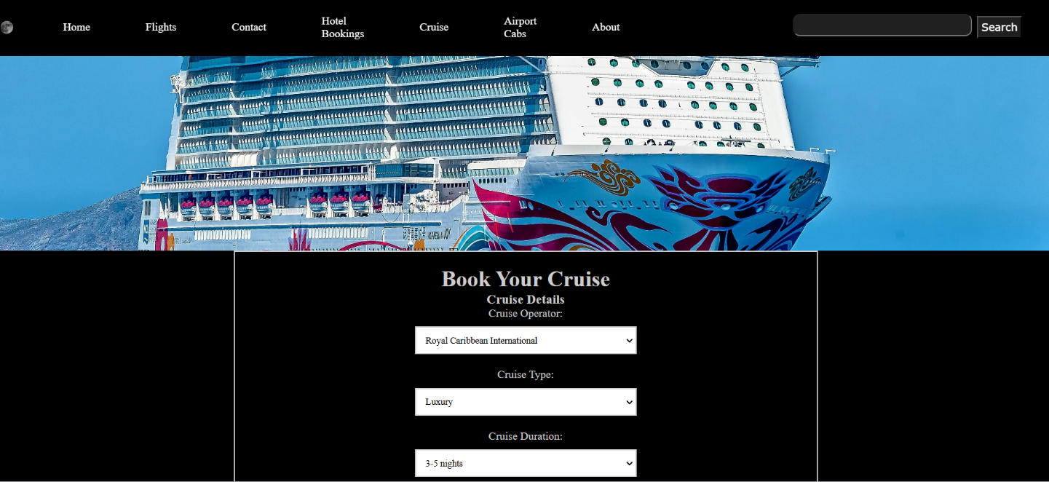

<!DOCTYPE html>

<html lang="en">

<head>

    <meta charset="UTF-8">

    <title>Cruise Booking Form</title>

    <link rel="stylesheet" href="ccruise.css">

    <link rel="stylesheet" href="https://stackpath.bootstrapcdn.com/font-awesome/4.7.0/css/font-awesome.min.css">

</head>

<body>

    <nav class="navbar background">

        <ul class="navlinks">

           <div class="logo"><img src="moon.png" alt="logo"></div>

           <li><a href="proj.html">Home</a></li>

           <li><a href="flight.html">Flights</a></li>

           <li><a href="ourcontact.html">Contact</a></li>

           <li><a href="hotel.html">Hotel Bookings</a></li>

           <li><a href="cruise.html">Cruise</a></li>

           <li><a href="cab.html">Airport Cabs</a></li>

           <li><a class="active" href="about.html">About</a></li>

        </ul>

        <div class="rightnav">

           <input type="text" name="search" id="search">

           <button class="btnsm"> Search </button>

        </div>

    </nav>

    <div class="header-image">

        <img src="mariachi.jpg" alt="header Image" class="header-image">

    </div>

    <div class="omega">

        <div class="booking-form">

            <div class="form-content">

            <form>

                <h1>Book Your Cruise</h1>

                <h3>Cruise Details</h3>

                <div class="cruise-form">

                    <div class="item1">

                        <label for="c-operator">Cruise Operator:</label>

                        <select id="opp" name="opp">

                            <option value="royalcaribbeaninternational">Royal Caribbean International</option>

                            <option value="mediterraneancruise">Mediterranean Cruise</option>

                            <option value="norwegiancruiseline">Norwegian Cruise Line</option>

                            <option value="holland">Holland America Line</option>

                            <option value="disney">Disney Cruise Line</option>

                        </select>

                        <label for="cruise-type">Cruise Type:</label>

                        <select id="cruise-type" name="cruise-type">

                            <option value="luxury">Luxury</option>

                            <option value="budget">Budget</option>

                            <option value="family-friendly">Family-Friendly</option>

                            <option value="premium">Premium</option>

                            <option value="adventure">Adventure</option>

                        </select>

                        <label for="cruise-duration">Cruise Duration:</label>

                        <select id="cruise-duration" name="cruise-duration">

                            <option value="3-5 nights">3-5 nights</option>

                            <option value="6-8 nights">6-8 nights</option>

                            <option value="9-12 nights">9-12 nights</option>

                            <option value="13+ nights">13+ nights</option>

                        </select>

                        <label for="destination">Destination:</label>

                        <select id="destination" name="destination">

                            <option value="caribbean">Caribbean</option>

                            <option value="mediterranean">Mediterranean</option>

                            <option value="alaska">Alaska</option>

                            <option value="bahamas">Bahamas</option>

                            <option value="hawaii">Hawaii</option>

                        </select>

                        <h3>Traveler Information</h3>

                        <div class="item2">

                            <label for="first-name">First Name:</label>

                            <input type="text" id="first-name" name="first-name" required>

                            <label for="last-name">Last Name:</label>

                            <input type="text" id="last-name" name="last-name" required>

                            <label for="email">Email:</label>

                            <input type="email" id="email" name="email" required>

                            <label for="phone">Phone:</label>

                            <input type="tel" id="phone" name="phone" required>

                        </div>

                        <h3>Cabin and Accommodations</h3>

                        <div class="item3">

                            <label for="cabin-type">Cabin Type:</label>

                            <select id="cabin-type" name="cabin-type">

                                <option value="single">Single</option>

                                <option value="double">Double</option>

                                <option value="suite">Suite</option>

                                <option value="balcony">Balcony</option>

                                <option value="oceanview">Oceanview</option>

                            </select>

                            <label for="number-of-passengers">Number of Passengers:</label>

                            <input type="number" id="number-of-passengers" name="number-of-passengers" min="1" required>

                            <label for="bedding-preference">Bedding Preference:</label>

                            <select id="bedding-preference" name="bedding-preference">

                                <option value="king">King</option>

                                <option value="queen">Queen</option>

                                <option value="twin">Twin</option>

                            </select>

                        </div>

                        <h3>Dates and Itinerary</h3>

                            <label for="departure-date">Departure Date:</label>

                            <input type="date" id="departure-date" name="departure-date" required>

                            <label for="return-date">Return Date:</label>

                            <input type="date" id="return-date" name="return-date" required>

                            <label for="itinerary">Itinerary:</label>

                            <textarea id="itinerary" name="itinerary"></textarea>

                        <h3>Special Requests</h3>

                        <label for="special-requests">Special Requests:</label>

                        <textarea id="special-requests" name="special-requests"></textarea>

                        <label for="dietary-restrictions">Dietary Restrictions:</label>

                        <textarea id="dietary-restrictions" name="dietary-restrictions"></textarea>

                        <h3>Payment Information</h3>

                        <label for="card-type">Card Type:</label>

                        <select id="card-type" name="card-type">

                            <option value="visa">Visa</option>

                            <option value="mastercard">Mastercard</option>

                            <option value="amex">American Express</option>

                        </select><br><br>

                        <label for="card-number">Card Number:</label>

                        <textarea id="card-number" id="card-number" name="card-number"></textarea>

                        <label for="expiration-date">Expiration Date:</label>

                        <input type="date" id="expiration-date" name="expiration-date"><br><br>

                        <button type="submit">Book Now</button>

                    </div>

                </div>

            </div>

            </form>

        </div>

    </div>

</body>

<footer>

    <div class="footer-content">

        <h3>Travel Manager</h3>

        <p>Travel Manager is a  website where you will find .</p>

        <ul class="socials">

            <li><a href="#"><i class="fa fa-facebook"></i></a></li>

            <li><a href="#"><i class="fa fa-twitter"></i></a></li>

            <li><a href="#"><i class="fa fa-reddit"></i></a></li>

            <li><a href="#"><i class="fa fa-instagram"></i></a></li>

            <li><a href="#"><i class="fa fa-linkedin-square"></i></a></li>

        </ul>

    </div>

    <div class="footer-bottom">

        <p>copyright &copy;2024 <a href="#">Travel Manager</a>  </p>

    </div>

</footer>

</html>

* 1. **Airport Cab booking page**

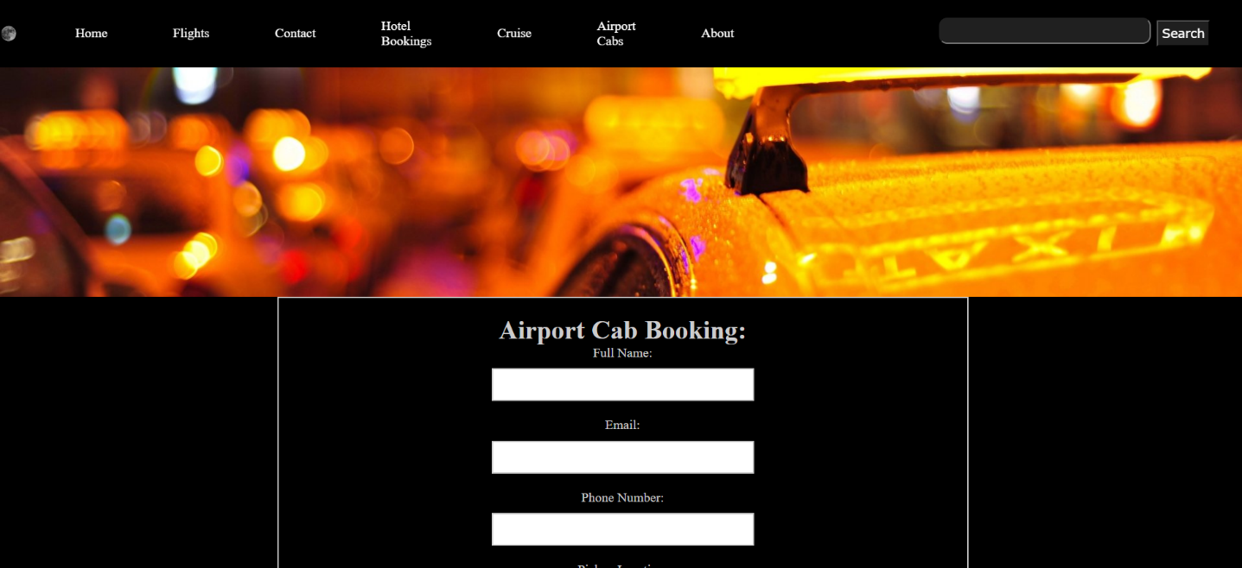

<html>

    <head>

        <link rel="stylesheet" href="cab.css">

        <link rel="stylesheet" href="https://stackpath.bootstrapcdn.com/font-awesome/4.7.0/css/font-awesome.min.css">

    </head>

    <body>

        <nav class="navbar background">

            <ul class="navlinks">

               <div class="logo"><img src="moon.png" alt="logo"></div>

               <li><a href="proj.html">Home</a></li>

               <li><a href="flight.html">Flights</a></li>

               <li><a href="ourcontact.html">Contact</a></li>

               <li><a href="hotel.html">Hotel Bookings</a></li>

               <li><a href="cruise.html">Cruise</a></li>

               <li><a href="cab.html">Airport Cabs</a></li>

               <li><a class="active" href="about.html">About</a></li>

            </ul>

            <div class="rightnav">

               <input type="text" name="search" id="search">

               <button class="btnsm"> Search </button>

            </div>

        </nav>

        <div class="header-image">

            <img src="taxi.jpg" alt="header Image" class="header-image">

        </div>

        <div class="omega">

            <div class="booking-form">

                <div class="form-content">

                    <h1>Airport Cab Booking:</h1>

                    <form action="#">

                        <label for="name">Full Name:</label>

                        <input type="text" id="name" name="name" required>

                        <label for="email">Email:</label>

                        <input type="email" id="email" name="email" required>

                        <label for="phone">Phone Number:</label>

                        <input type="tel" id="phone" name="phone" required>

                        <label for="pickup">Pickup Location:</label>

                        <input type="text" id="pickup" name="pickup" required>

                        <label for="dropoff">Drop-off Location:</label>

                        <input type="text" id="dropoff" name="dropoff" required>

                        <label for="date">Date of Travel:</label>

                        <input type="date" id="date" name="date" required>

                        <label for="time">Time of Travel:</label>

                        <input type="time" id="time" name="time" required>

                        <label for="vehicle">Type of Vehicle:</label>

                        <select id="vehicle" name="vehicle" required>

                            <option value="sedan">Sedan</option>

                            <option value="suv">SUV</option>

                            <option value="van">Van</option>

                        </select>

                        <h3>Payment Information</h3>

                        <label for="card-type">Card Type:</label>

                        <select id="card-type" name="card-type">

                            <option value="visa">Visa</option>

                            <option value="mastercard">Mastercard</option>

                            <option value="amex">American Express</option>

                        </select><br><br>

                        <label for="card-number">Card Number:</label>

                        <textarea="text" id="card-number" name="card-number"></textarea><br><br>

                        <label for="expiration-date">Expiration Date:</label>

                        <input type="date" id="expiration-date" name="expiration-date"><br><br>

                        <button type="submit">Book Now</button>

                    </form>

                </div>

            </div>

        </div>

    </body>

    <footer>

        <div class="footer-content">

            <h3>Travel Manager</h3>

            <p>Travel Manager is a  website where you will find .</p>

            <ul class="socials">

                <li><a href="#"><i class="fa fa-facebook"></i></a></li>

                <li><a href="#"><i class="fa fa-twitter"></i></a></li>

                <li><a href="#"><i class="fa fa-reddit"></i></a></li>

                <li><a href="#"><i class="fa fa-instagram"></i></a></li>

                <li><a href="#"><i class="fa fa-linkedin-square"></i></a></li>

            </ul>

        </div>

        <div class="footer-bottom">

            <p>copyright &copy;2024 <a href="#">Travel Manager</a>  </p>

        </div>

    </footer>

</html>

# 7.SUMMARY AND CONCLUSIONS

## LIMITATIONS OF THE SYSTEM

## Current limitations of the system include lack of backend significantly constrains the website's functionality. Without server-side processing, the application lacks data storage capabilities, making it impossible to maintain user accounts, or implement secure authentication mechanism. Additionally, the lack of a backend prevents the implementation of real-time features, dynamic content updates, and proper API management, ultimately resulting in a static experience that cannot adapt to user interactions or scale effectively with growing demands.

## CONCLUSION

.

## Future Enhancement

There is a wide scope of enhancement in our project .Following Enhancements can be done Including having backend for the storage of data, user content and lack of API frameworks which can automate various real time tasks and using of analytical tools and API to offer enterprise-level tools for travel managers to optimize budgets, track spending, and identify cost-saving opportunities. As the platform expands to globally demand for seamless experience while using the service. It can help in tourism activities of regions and places helping people.

# 8. REFERENCES

* <https://www.w3schools.com/>
* <https://javatpoint.com//>